Assignment dated on 1st of October

From the following table solve the given questions:

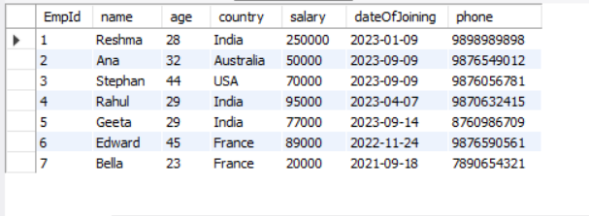

1. Write a SQL query to find the number of employees living in each country.
2. Write a query to find the highest salary of employees in each country having salary more than 70000.
3. Write a query to add an email column in the existing employee table.
4. Write a query to update the age of an employee to 55 and salary to 90000 where id is 4.
5. Write a query to rename a column country to address
6. Write a query to delete the age column.
7. Write a query to extract only the first three records from the given table.

**Customer**

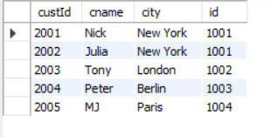

**Salesman**

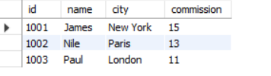

1. Write a sql query to return all of the records from customer table but only matching records from salesperson table using joins.
2. Write a SQL query to find the salesperson and customer who reside in the same city.
3. Write a SQL query to find salespeople who received commissions of more than 11 from the company. Return cname, customer city, name of salesman, commission.